**Release Notes:**

Kindly follow the Below steps to create a vertical environment and crate a Django project .

Step1: Install the virtualenvwrapper and run it.

pip install virtualenvwrapper-win

Running it:

mkvirtualenv <name> (ex:Share_Thought)

to reconnect:

CMD: workon Django_Practice

Step2: Install Django and Create a Django Project.

django-admin startproject <project_name>(ex: Share_thought)

this will create a project dir in the location where you have run it.

/Share_thought/Share_thought

2.1 Run the following command to kickstart the server.

manage.py runserver

ex: http://127.0.0.1:8000/

2.2 Now create an app with name of your choice but to follow this project let’s assume take it as “thought”

python manage.py startapp <name> (thought)

Change the Following files in the below mentioned directors. Change them by cloning them from GIT location ():

Step3: Replace the following files with the files in GIT I followed the same Directory path.

3.1Replace all the files in this location with GIT.

C:\<your local path> \Share_thought\Share_thought\settings.py

\urls.py

\wsgi.py

Clone the following Directories completely into your local.

C:\<your local path> \Share_thought\static

C:\<your local path> \Share_thought\thought

Step4: Clone the following files too from git to the below location.

C:\<your local path> \Share_thought\.gitignore.txt

Following are the 4 files which are mandatory to check in the code to HEROKU Cloud.

C:\<your local path> \Share_thought\Procfile

C:\<your local path> \Share_thought\requirements.txt

C:\<your local path> \Share_thought\runtime.txt

C:\<your local path> \Share_thought\uwsgi.ini

Note install the requirements,txt

Pip install -r requirements.txt

Now Run the Following steps to set up the complete project.

Step5:

5.1 This command will show the all the details of migrations.

python manage.py showmigrations

5.2 This command will do all the necessary migrations

python manage.py migrate

5.3 Create an admin user as following.

python manage.py createsuperuser

Fill the necessary information

Now run the Server in your Local to check the Deployment.

Python manage,py runserver

Now open the local host and log in to admin and add a Topic so that the Root will run.

This Project is Hosted in Heroku Cloud, click on the Below url.

<https://share-thought.herokuapp.com/>

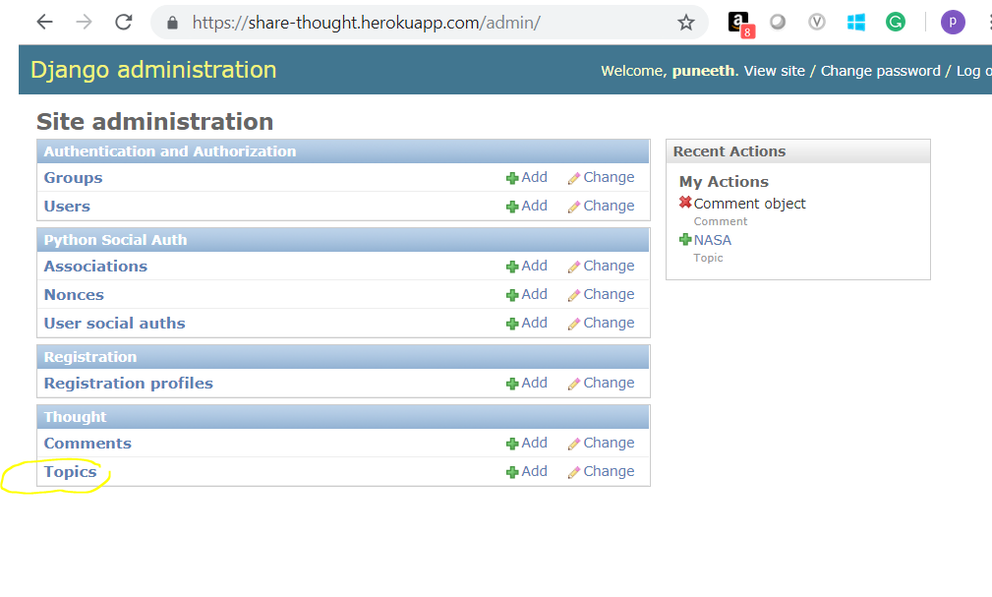

And the home page something this.

